Name and address

SPECIAL ONE-TIME ONLY OFFER TO TECH-NI-FOLD CUSTOMERS
Celebrating The Launch Of The NEW Tri-Creaser ADVANCE

Invest in the NEW Tri-Creaser ADVANCE And SAVE £750.00

OFFER EXPIRES 25TH MAY

Hi firstname,

We recently launched our best-of-breed Tri-Creaser ADVANCE. As one of my valued customers, you can get the ADVANCE for £750.00 less than the normal price. The only catch is this is a one-time only offer and it expires on Friday May 25th.

The ADVANCE is our next generation creasing device that totally eliminates fibre-cracking on every type of stock INCLUDING digital stocks.

I estimate that since the launch of the very first Tri-Creaser back in 1999, our revolutionary devices have saved printers and print finishers over £8 BILLION. Such is the technological innovations included in the ADAVANCE, I truly believe we’ll triple this saving in the next 3 years!

…and I’d love you to be part of this revolution in creasing technology, so you too can save more time and money and improve the quality of your creasing work.

I can’t tell you how thrilled I am that you put your trust and belief in the Tech-ni-Fold range of products and this one-time-only offer is my way of saying ‘thanks’ for all your support over the years.

In fact, here’s why the ADVANCE is already having such a huge impact…

The Tri-Creaser Advance is the world's first and only folding machine solution designed to prevent fibre-cracking on the outside of the fold and tackle inside-fold toner flaking AT THE SAME TIME.

Over, please…

To demonstrate exactly how this is achieved, we’ve created a stunning video along with more information on how you can take advantage of this customer only special offer. You can watch the video here (please note, this is ONLY for existing Tech-ni-Fold customers, please do NOT share with any other printers/print finishers)…

advance.technifold.com

As you’d expect, the ADVANCE comes with our now legendary 90-Day No Questions Asked Money-Back Guarantee.

Here’s how it works…

Just give the Tri-Creaser ADVANCE a try over the next 90 days and if for whatever reason you don't want to keep it, send it back for a full refund. No questions asked!

Whilst it’s highly unlikely you’ll want to send it back (it will improve your creasing work and save you £hundreds each month) my view has always been that my customers should never shoulder any risk when they buy from us.
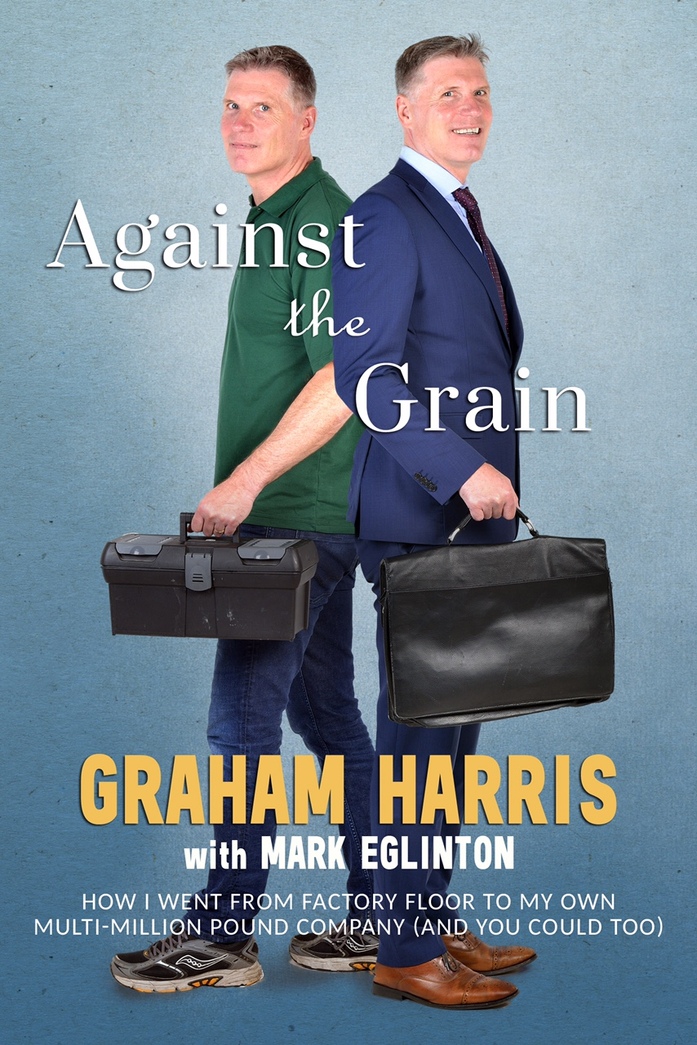
FREE BONUS: Get My New Book

And as an extra incentive, the first 50 customers who order the Tri-Creaser ADVANCE will also receive my new Amazon Best-Selling book titled, “Against The Grain”. The book explains how I took my invention (the Tri-Creaser) and transformed it into an internationally recognised product serving the printing industry.

There are many anecdotal stories on entrepreneurship and building businesses, which I’m sure you’ll get a lot out of.

Offer Ends – 25th May

Remember, to take advantage of this one-time-only offer, you have to invest in the Tri-Creaser ADVANCE before 5pm on May 25th. You can get all the details here: advance.technifold.com or call us on 01455 554 491.

Kind regards,

Graham Harris, Managing Director

P.S. If you need any proof, here’s what one of our customers has said about the ADVANCE…

“We run a 300gsm silk job for a perfume brand. The job is laminated on the outside but not on the inside. The Tri-Creaser Advance gives it a beautiful square crease result on the inside of the fold by producing a deeper impression. The Tri-Creaser Advance is an improvement even on previous versions.” – Tony Puxty, Fontain, London, UK

